Rosanna Cubs
– Swimming night
WaterMarc Greensborough
Tuesday 23rd March, 6:30pm-8pm

This week, we’ll be going swimming (and sliding) at WaterMarc in Greensborough. This will be a fun night rather than a badge night – Cubs will have a swimming night later in the year for Swimming Badges.

- 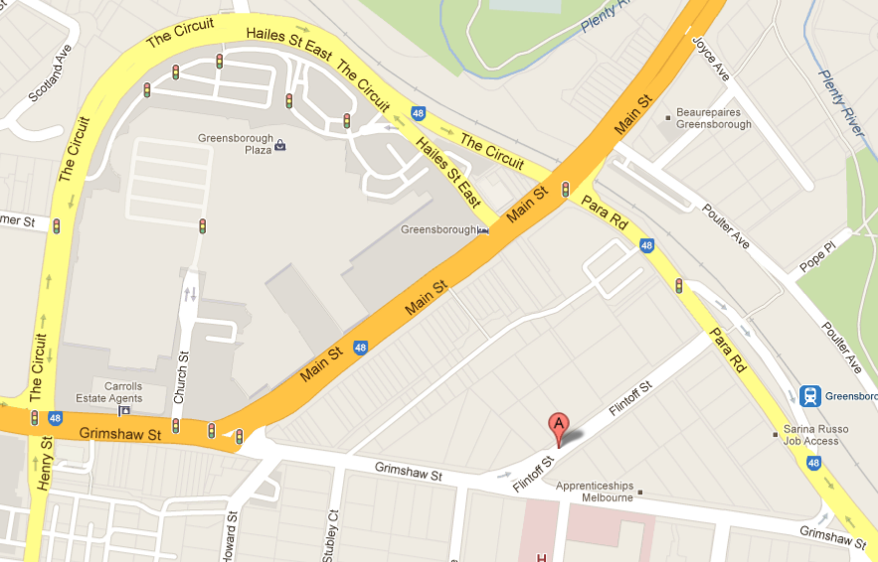Time: 6:30-8pm – Note different time
to normal Cubs. Pool is open later
for families who choose to stay on.
- Cost:
  - Swim & Waterslides $13.25
  - Swim only $6.10
  - Slides Only, if you already have swim membership $7.70 (using child m’ship)
  - Entry only (no swim/slide) $3
NOTE: the slides will only be open till 7pm. So you need to decide if the extra cost is worth it for the half hour
PLEASE BRING CORRECT MONEY AMOUNT

- There are height rules for the Waterslides (slides open until 7:00pm)
  - Taller than 122cm = can go on all slides
  - 107cm<122cm = can go on Pipeline
  - Shorter than 107cm = can’t go on waterslides
…..To save time, please know your Cub(s)’ height and bring the appropriate money as per ‘Cost’ above.

- Location: WaterMarc Aquatic Centre –
1 Flintoff St, Greensborough
- Bring: Togs, Towel, EXACT money for your entry, & warm clothes to go home in, plus swim goggles, snacks/drink bottle if you want them.

Don’t miss out – see you there!

Regards

The Leaders
Rosanna Cub Scouts

See Rosanna Cubs at http://www.rosannacubs.org

